|  |
| --- |
| Top menu |

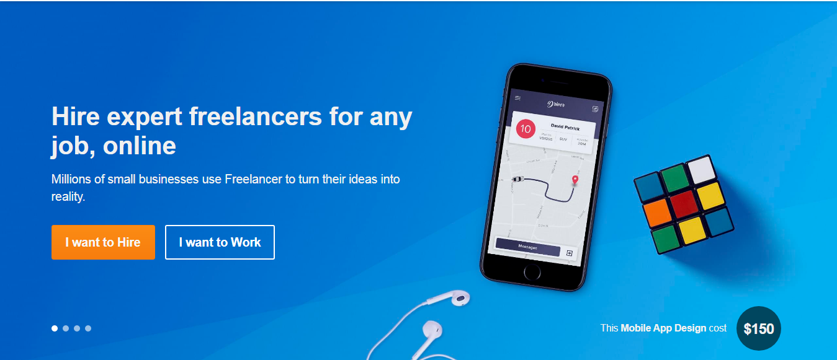

## Solve a Challenge

Launch a Challenge

|  |
| --- |
| Video |

